Introduction to Robotics

Report for Project 1

Abstract and Summary

In this report we will use the Denavit-Hartenberg, or D-H parameter to computer the forward kinematic movement of each finger. This is a very widely used and basic principal to compute the basic calculation of how the robot should perform in theory and in practical use. DH parameters allows us to visualize where the arms of the robot would be given the angles and the distance to and from each joint. This report is to portray the understanding of the material in the class and further strengthen one’s ability to understand the mechanics involved in robotic movement by simply following an example of a human hand.

Materials used

* Robotic Glove
* Sensor
* Computer
* Ruler
* Protractor

Goal

To visualize the finger position and coordinates given the distance and the angles.

For the simplicity of our calculation we have ignore the tip link of our finger as it depends on the previous linked joint (DIP)

We have used our DH parameters of each finger in a following format.

|  |  |  |  |  |
| --- | --- | --- | --- | --- |
| Joints | a | α | d | Ѳ |
| Link 1 | Distance from link 0 to link 1 | Coordinate system | Displacement of x axis | Angle of the joint 1 |
| Link 2 | Distance between link 1 to link 2 | Coordinate system | Displacement of x axis | Angle of the joint 2 |
| Link 3 | Distance between link 2 to 3 | Coordinate system | Displacement of x axis | Angle of the joint 3 |
| Link 4 | Distance between link 3 and 4 | Coordinate system | Displacement of x axis | Angle of the join 4 |

Equations used to obtain the DH parameters and Forwards kinematic Moments

**Forward kinematic of the index finger Using DH Parameters**

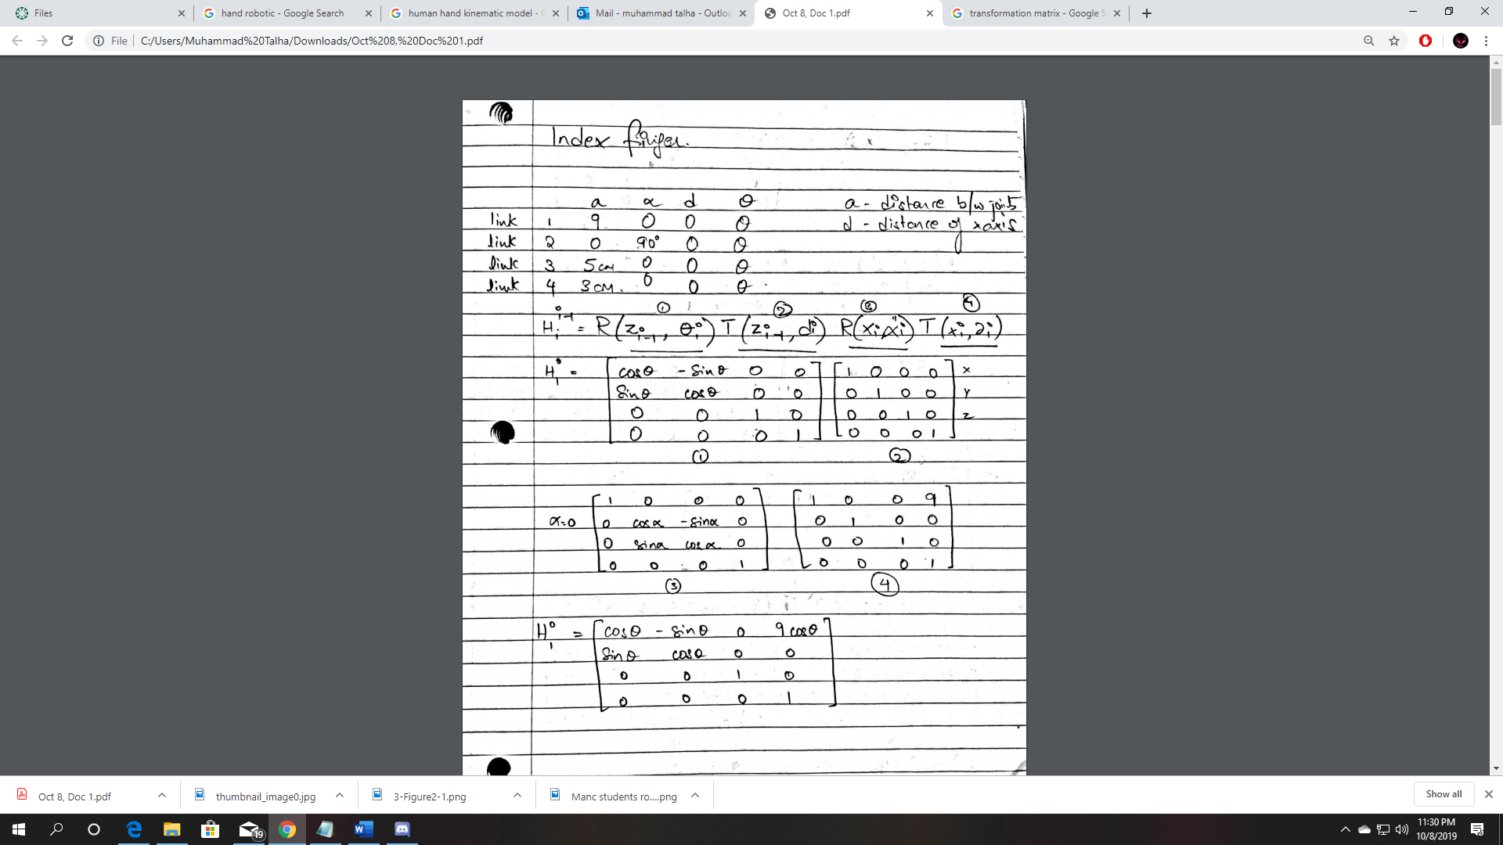

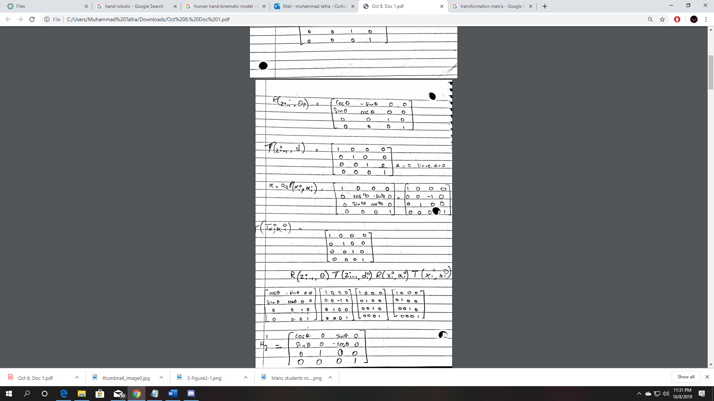

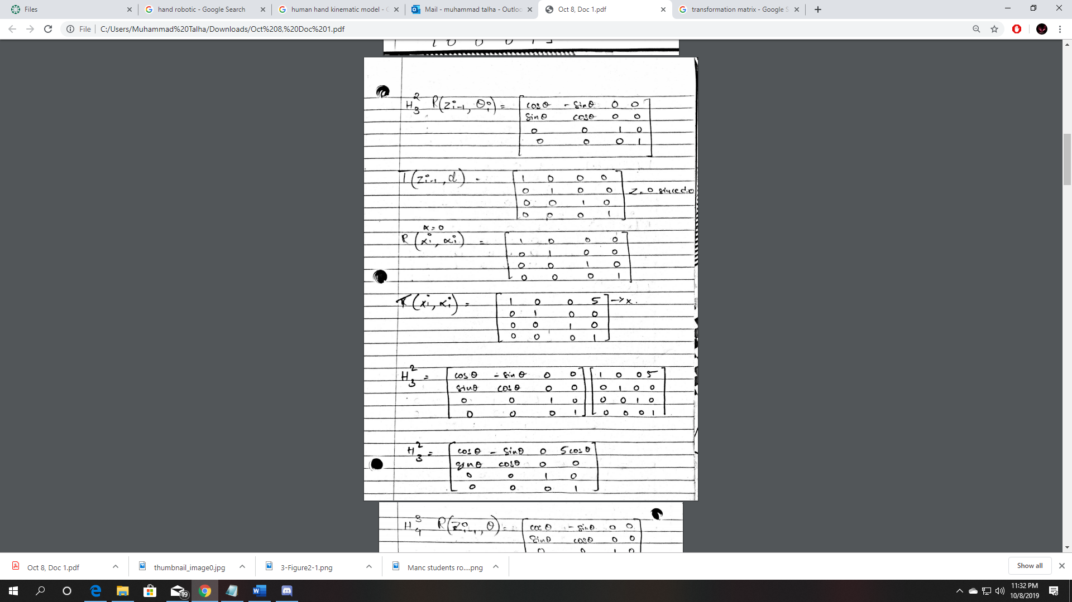

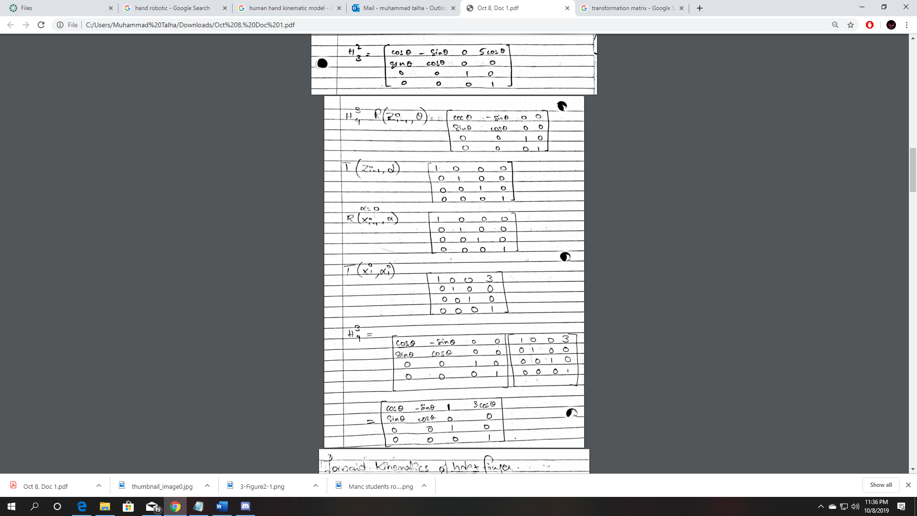

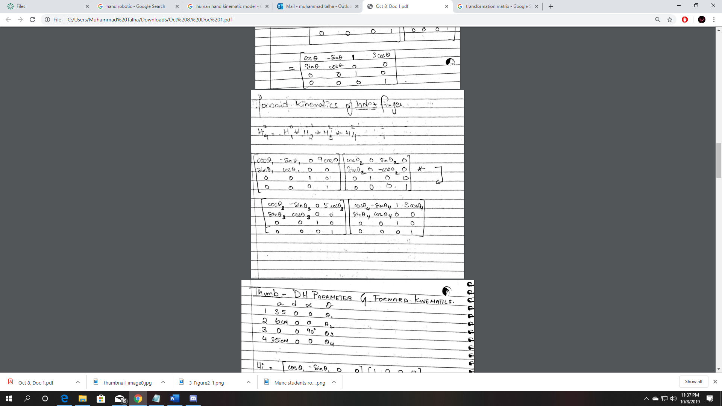

**Forward Kinematic Movement of the Thumb using the DH parameters**

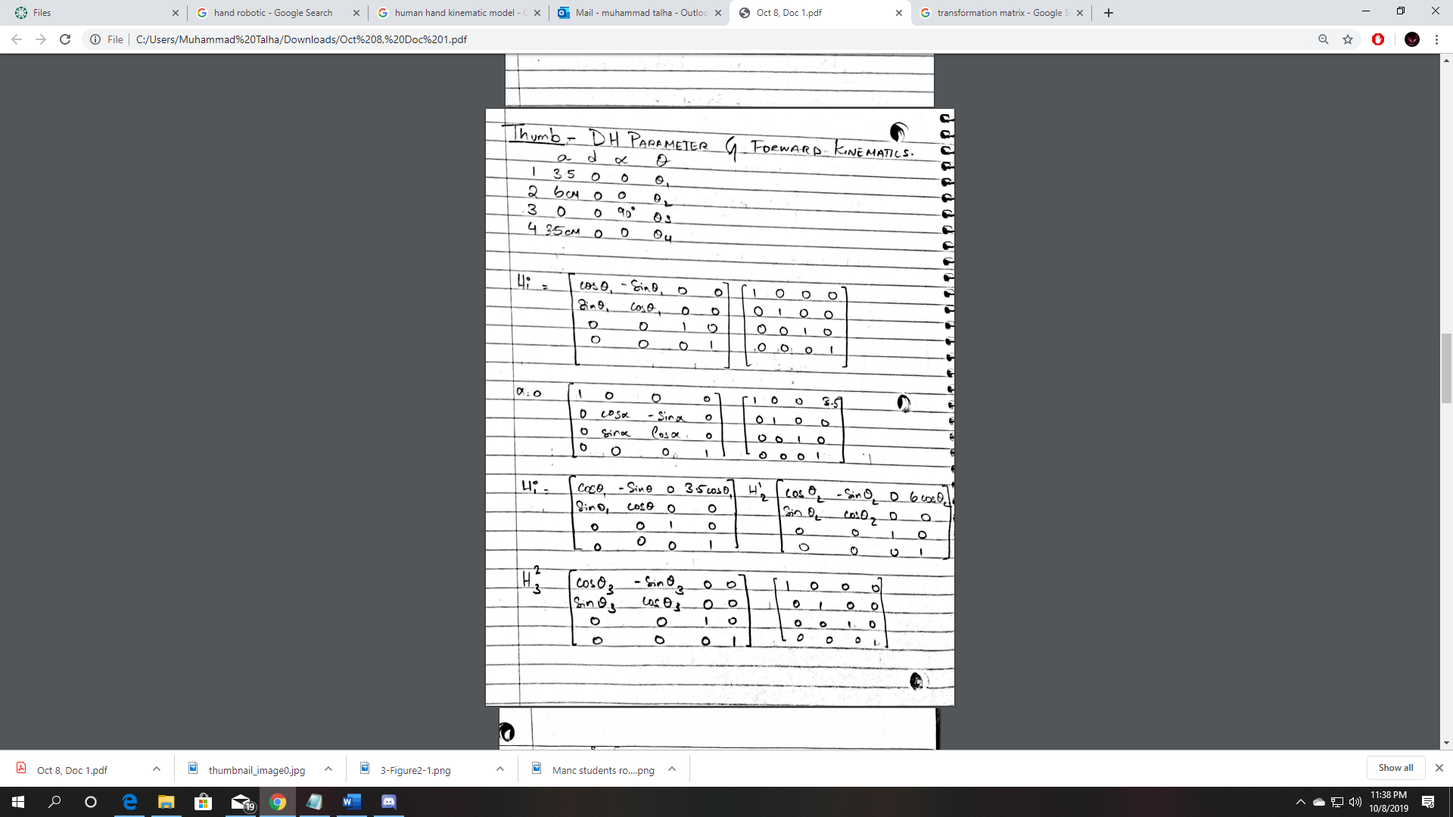

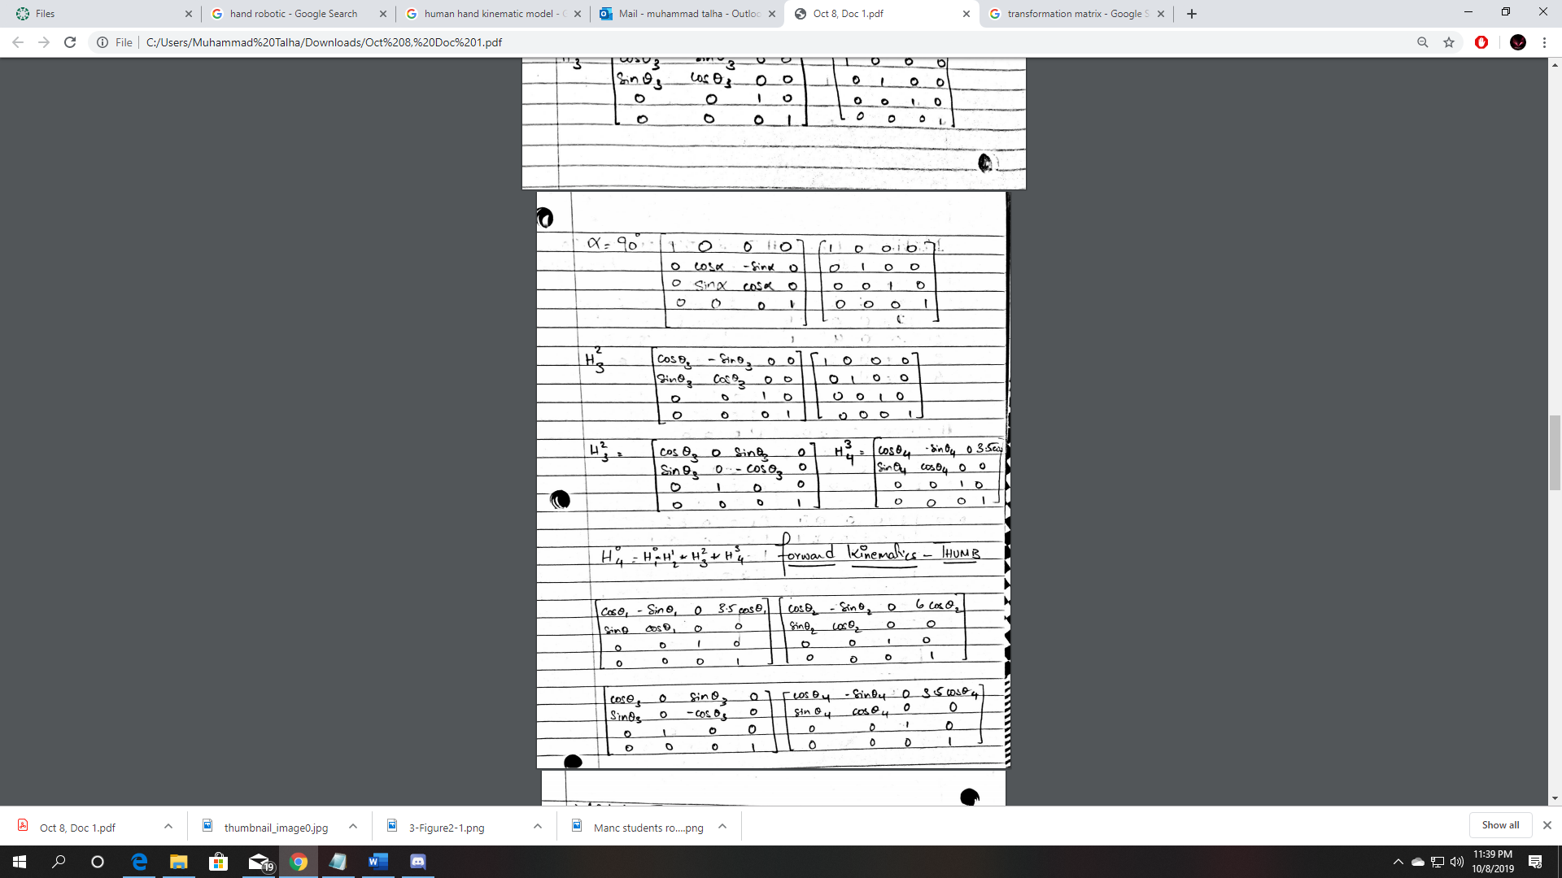

**Forward Kinematic Movement of the Middle Finger using DH Parameters**

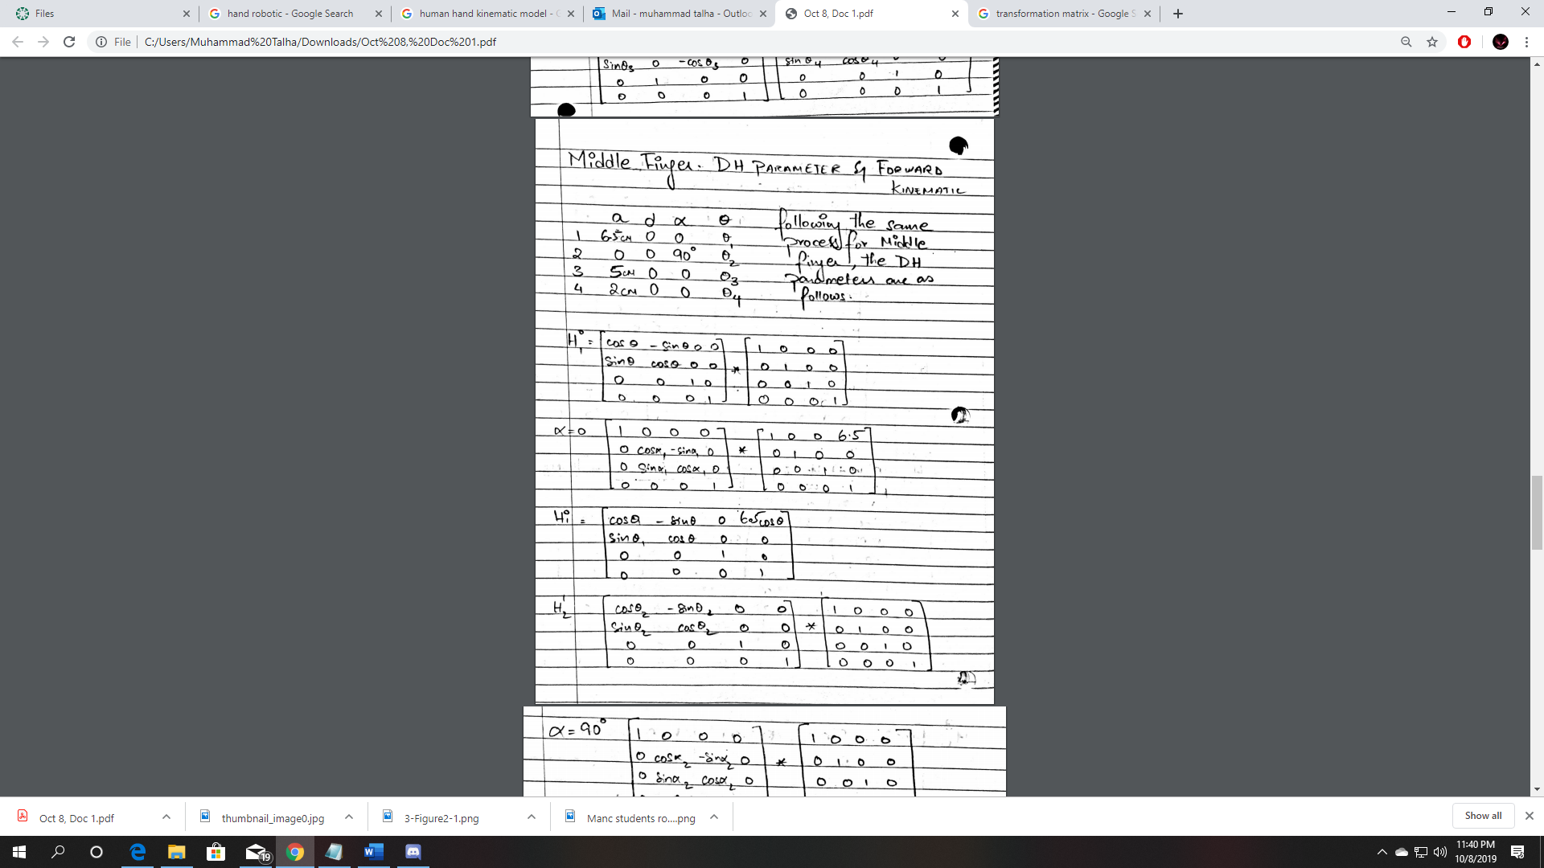

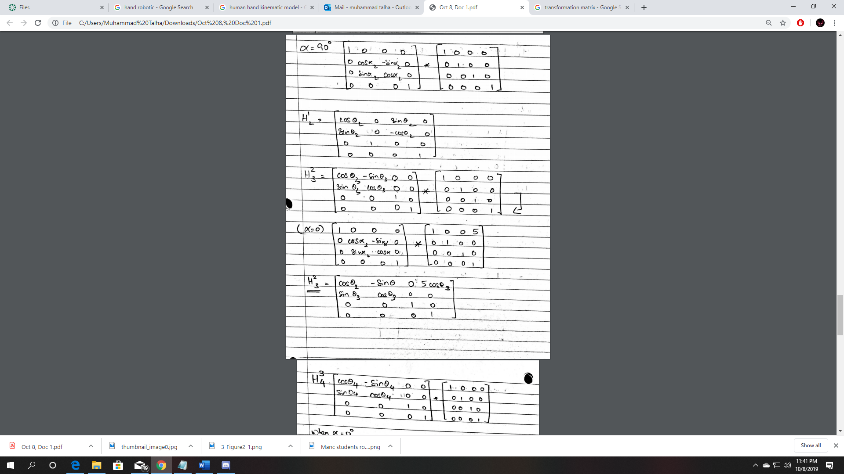

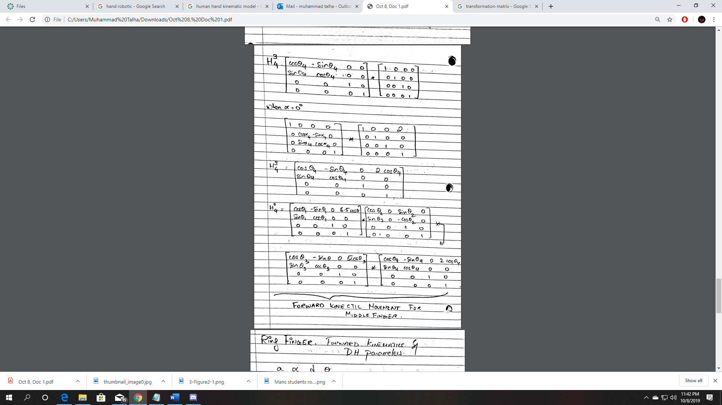

**Forward Kinematic Movement Of the Ring Finger Using DH Parameters**

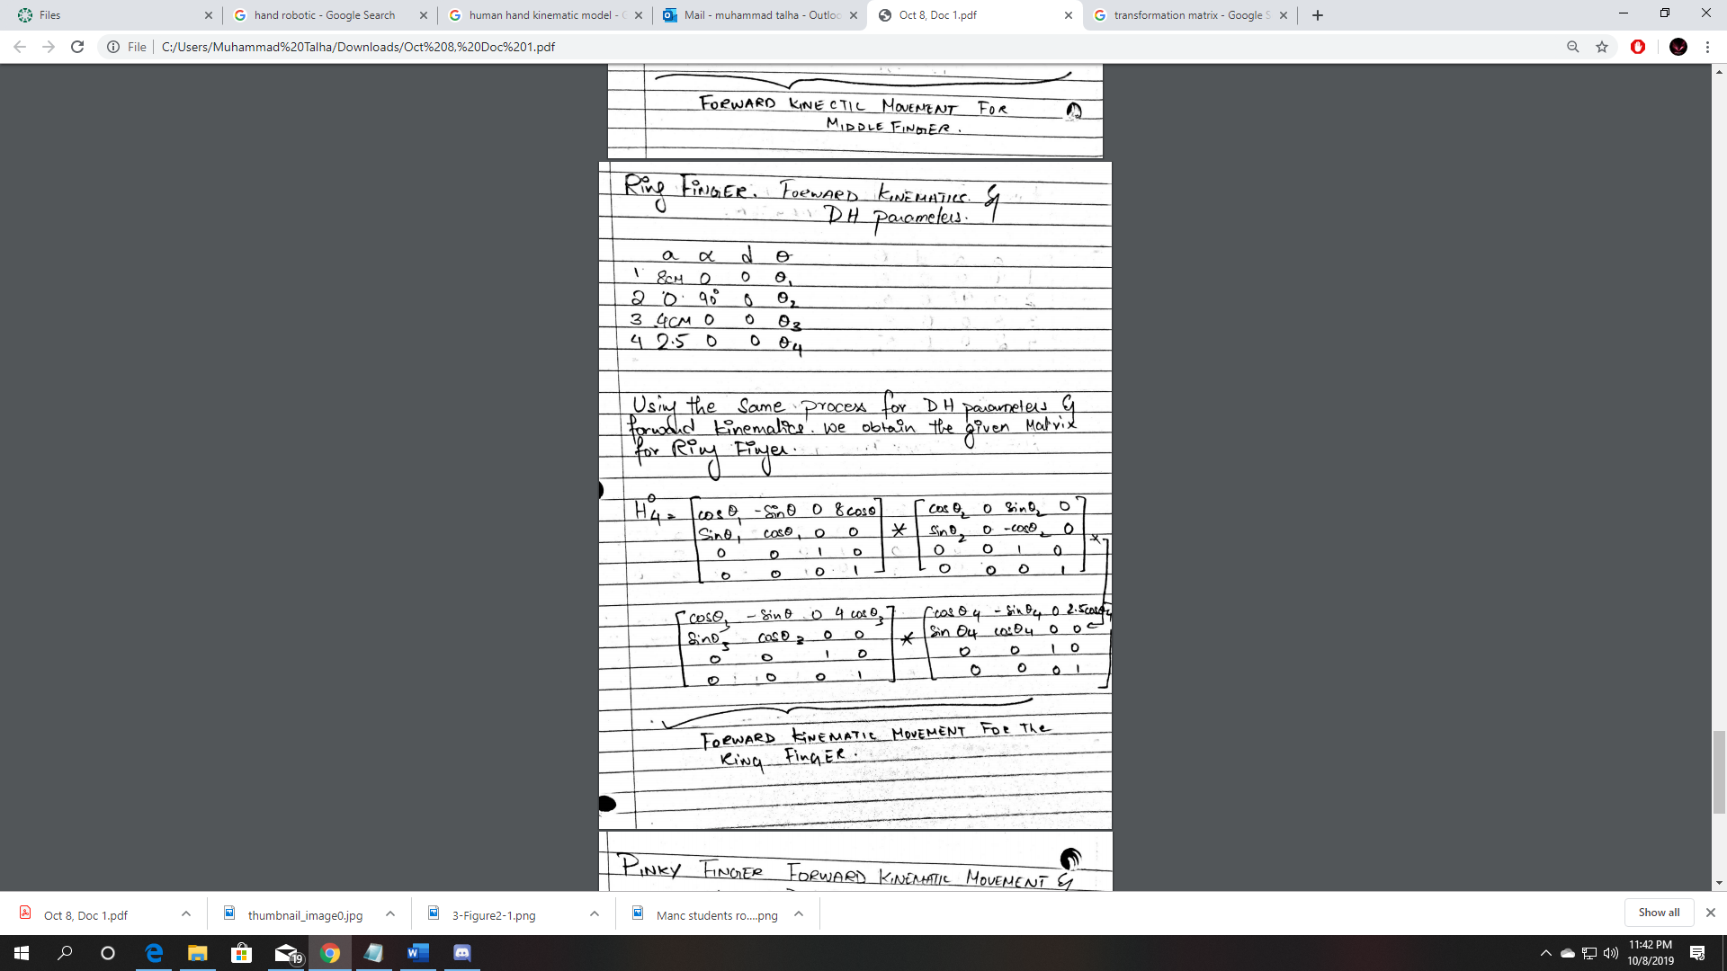

**Forward Kinematic Movement of the Pinky Finger Using DH Parameters**

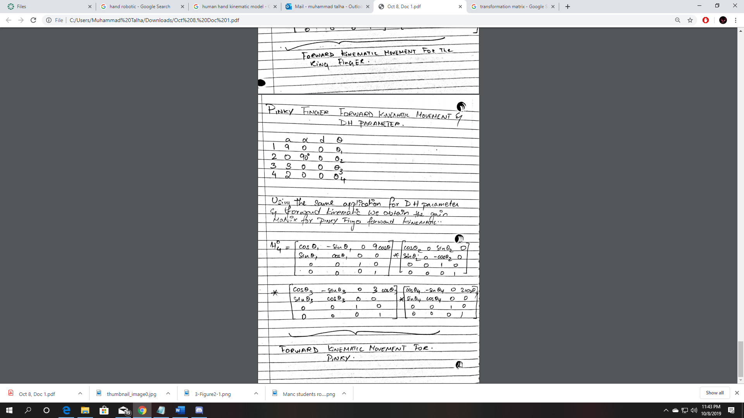

**Note**

In All the above examples the value of theta can be replaced with the values on the excel sheet. With the help of the obtained final matrix of and substituting the values in for theta, the position of the finger can be computed.

Values of Alpha has only changed on the second joint or link as it has 2 different coordinate systems since it is a Prismatic joint. We have rotated it 90 degrees along the X axis to find its reference of frame.